Full Paper Title in Title Case

AUTHOR1 ¹, AUTHOR2*²
(1. Affiliated Institutions of Author1; 2. Affiliated Institutions of Author2)
E.g.: 1. College of Transportation Engineering, Chang'an University;

Abstract: In this paper, the formatting requirements for the inaugural World Transport Convention (WTC) are described. Some recommendations on writing for a worldwide readership are offered. Please review this document to learn about the formatting of texts, table and figure captions, references, and the method to include the indexing information. The full paper shall be written in compliance with these instructions.

Keywords: keyword1; keyword2; keyword3; keyword4 (No more than 7 keywords)

Introduction
It is expected that authors will submit carefully written and proofread material. Careful checking for spelling and grammatical errors should be performed.
Papers should clearly describe the background of the subject, the work of the author(s), including the methods used, results and concluding discussions on the importance of the work. Papers are to be prepared in English and SI units must be used. Technical terms should be explained unless they may be considered to be known to the conference community.
Please avoid using maps. The Executive Committee of WTC has the right to delete the map content according to the review needs.

Paper Format
The uniform appearance will assist the reader to read paper of the proceedings. It is therefore suggested to authors to use the example of this file to construct their papers. This particular example uses an American letter format with 25 mm margins left, right, top and bottom.
All text paragraphs should be single spaced, with first line intended by 10 mm. Double spacing should only be used before and after headings and subheadings as shown in this example. Position and style of headings and subheadings should follow this example. No spaces should be placed between paragraphs.

Header, Footer, Page Numbering
Authors are asked to insert page number in the footer section and the conference information on the header of the first page.

Fonts
Papers should use 11-point Times New Roman font. The styles available are bold, italic and underlined. It is recommended that texts in figures should not smaller than 10-point font size.

Tables and Figures
Figure captions and table headings should be sufficient to explain the figure or table without needing to refer to the text. Figures and tables not cited in the text should not be presented. The following is an example for Table 1.
Table 1 Title of the Table
Year | Traffic Volume (pcu) | Speed (km/h)
2008 | 4700 | 40
2009 | 4800 | 39
2010 | 4900 | 38
2011 | 5000 | 38

Tables and figures should be placed close after their first reference in the text. All figures and tables should be numbered with Arabic numerals. Table headings should be centred above the tables. Figure captions should be centred below the figures as shown in Figure 1.

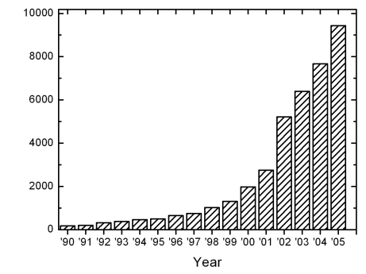
Volume
Figure 1: Traffic Volume on Highway 1

Equations
Each equation should be presented on a separate line from the text with a blank space above and below. Equations should be clear and expressions used should be explained in the text. The equations should be numbered consecutively at the outer right margin, as shown in Eqs. (1) - (2) below. Here is one example.
In this case, the governing system of equations can be written as follows:
()
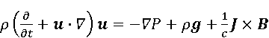 ()
(3)

References
Proper references must be included throughout the text and the list of references must be provided in this section. The references inserted in the text and the list of references must be done as follow:
Reference citations: Citations in the main body, appendices, tables and figures are to be made using the last name of the author (both authors when only two; first author plus et al. when more than two). Example: "... as previously shown (Jones et al., 1989)," or "... as shown by Jones et al. (1989)." For two or more papers published in the same year by the same author(s), add a, b, c, etc. to the year such as (1980a) or (1980b) and cite jointly as Jones et al. (1980a, b).
List of references: List all cited references (including citations in tables, figures and appendices) in alphabetical order according to the first-named author. The titles of papers, patents and books or monograph chapters and the initial and final page numbers are to be included. Example for journal papers, book/monograph sections or chapters, and conference proceedings are given the reference section at the end of this document.
Referencing websites: With the increasing availability of useful information that can be found on the internet, website references must also be reported. At the end of the reference list, make a separate section of websites and the date consulted. However, to avoid very long website addresses, these references should be referred as Web-1, Web-2, etc. In the reference list, provide the list of websites with the numeral values used in the text.

Submitting The Paper
The full paper has to be submitted electronically via the website of the conference (https://en.wtc-conference.com/). To ensure a successful submission, the file should be named with only English letter and numbers, as characters other than English letter could potentially cause submission failures.

Conference Program And Proceedings
The abstracts and full manuscripts may be compiled into the conference Proceedings or Abstract Compendium.

Conclusions
Conclusions should state concisely the most important propositions of the paper as well as the author’s views of the practical implications of the results.

References
[1] Heider E R, D C Oliver. The structure of color space in naming and memory of two languages [J]. Foreign Language Teaching and Research, 1999, (3): 62 – 67.
[2] Gill R. Mastering English Literature [M]. London: Macmillan, 1985.
[3] Almarza G G. Student foreign language teacher’s knowledge growth [A]. In D.Freeman and J.C.Richards (eds.). Teacher Learning in Language Teaching [C]. New York: Cambridge University Press. 1996:50-78.
[4] Hausler EA. Influence of ground improvement on settlement and liquefaction:a study based on field case history evidence and dynamic geotechnicalcentrifuge tests[D]. Berkeley:University of California, 2002.
[5] Expert A. Paper Title[EB/OL]. (2001-12-19)[2002-04-15]. http://www.reader.com/news/20011219/200112190019.html.

